MINISTRY OF GENERAL EDUCATION
MATHEMATICS AND COMPUTER STUDIES DEPARTMENT
GRADE 11 END OF TERM 3 EXAMS -2020
COMPUTER STUDIES

Total marks 100( 50)

STUDENT NAME…………………………………………………. . CLASS…. .DURATION 1H-30MIN

(1) Explain the meaning of the following computer terms
(a)binary number system…………………………………………………………………...........................
…………………………………………………………………………………………………………………………………….....[1]
(b)Flowchart………………………………………………………………………………………………………………
…………………………………………………………………………………………………………………………………………[1]
© Website……………………………………………………………………………………………………………………
…………………………………………………………………………………………………………………………………………[2]
(2) Give one difference between
(a) Microsoft word and Microsoft Access……………………………………………………………………
………………………………………………………………………………………………………………………………………..[2]
(b)Analog digital convertor and Digital Analog convector …………………………………………………………………………………………………………………………………………………………………………………………………………………………………………………………………………………………[2]
(c) Delete command and Drop command …………………………………………………………………………………………… …………………………………………………………………………………………………………………………………………[2]
(d)Microsoft word and Microsoft access……………………………………………………………………..
…………………………………………………………………………………………………………………………………………[2]

(3 )a Explain the meaning of the term data.
………………………………………………………………………………………………………………………………..
(b) State two input devices which automatically captures data
Device 1:……………………………………………………………………………………………………….. [1]
Device 2:……………………………………………………………………………………………………….. [1]

( c) Give an application which uses device 1 and another which uses device 2 from the above.
Device 1:Application……………………………………………………………………………….. [1]
Device 2:Application……………………………………………………………………………. [1]
( d) Give one advantage of using device 1 in the application you have named ……………………………………………………………………………………………………………………………… [1]

(4) (a) Convert (11001)₂ to decimal

[2]

b) Convert (51)₁₀ to binary.

[ 2]

(c) Convert (77)₁₀ to hex

[2]

5 (a) Below is the truth table for XOR gate. Complete the truth table to show the sum and the c-out.
X | Y | S | C-OUT
0 | 0
0 | 1
1 | 0
1 | 1
[4]
B) Using the complete truth table for XOR gate, make a half adder.

[3]

(6) The diagram below shows a local Area Network (LAN). Use it to answer questions that follow.

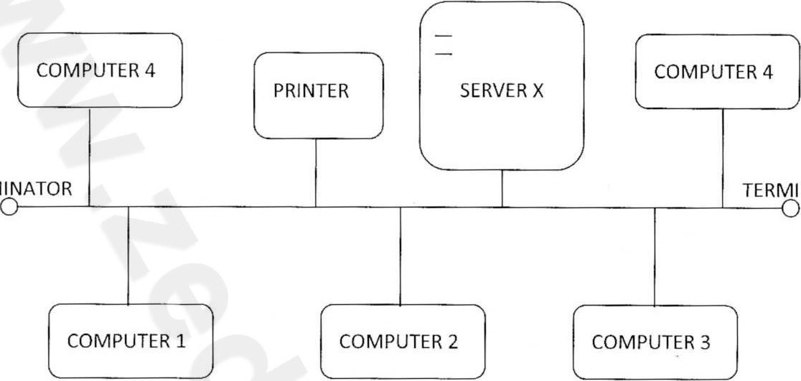TERMINATOR
TERMINATOR

(a)What name is given to this type of topology……………………………………
…………………………………………………………………………………………………... [1]
(b) Give one advantage and one disadvantage of this type of topology?.............................................................................................................
……………………………………………………………………………………………………………….
…………………………………………………………………………………………………………………
………………………………………………………………………………………………………………………. [2]

(C) Explain one function of the server X…………………………………………………………………
…………………………………………………………………………………………………… ………… [2] (d) Mention one item shared in this topology…………………………………………… [1]

(7) A table of fields in a database can be created using SQL.

Table name: Classes
Fields | Datatype | Length | Not null | Primary  key
First_Name | Varchar | 12 | Not null
Last_Name | Varchar | 15 | Not null
Class | Varchar | 3 | Not null | Class
Age | Int | 2 | Not null

(a) Write an SQL statement in Microsoft access that can be used to create a table with the following properties in a database.

[8] (b) Write an SQL Statement that can be used to view the properties of the created table above

[2] (C) Write an SQL statement that can be used to insert the following records in the database table.
First_Name | Last_Name | Class | Age
John | chishimba | 11 | 18

[4]

